**Assignment 2:**

1. **Difference between Npm and Npx in React**

* npm is a tool mainly used to install packages.
* npx is a tool to execute packages.

If you want to execute a package without installing it on your computer and then launch it you can use npx directly.  
Speaking of react , create-react-app is an utility to bootstrap a react project: if you use it with npx ( npx create-react-app my-app ) you will have your my-app project in place without the need to install create-react-app itself ( which will need another passage: npm install create-react-app and then create-react-app my-app)

1. **How to change the react application port (default port=3000)**

Port can be changed by any one of the following methods.

* 1. Setting environment variable

To set the environment variable, we need to open the command line terminal and add a set a new environment variable for ReactJS port.

**C:\MYPROJECT> SET PORT=8000**

## Modifying package.json

To change the development server port to port 8000, we need to modify the value of “**start**” key as follows:

**"scripts": {**

**"start": “set PORT=8000 && react-scripts start",**

**"build": "react-scripts build",**

**"test": "react-scripts test --env=jsdom",**

**"eject": "react-scripts eject"**

**}**

## Creating .env file

The .env file should be created in the root directory of the React project. In other words, it resides in the same directory with package.json. If we change the React development server port to 8000, the content of .env file will be as follows.

**.env**

**PORT=8000**

1. **Explain the Execution flow of a React App**

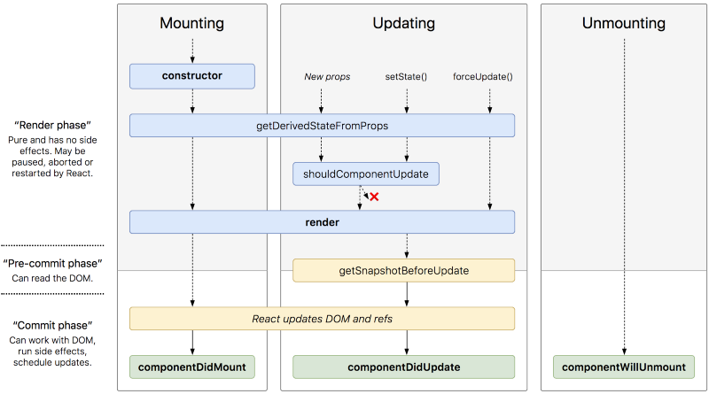

1. **What is Strictmode in ReactJs**

StrictMode is a tool for highlighting potential problems in an application. Like Fragment, StrictMode does not render any visible UI. It activates additional checks and warnings for its descendants.

StrictMode currently helps with:

* + - [Identifying components with unsafe lifecycles](https://reactjs.org/docs/strict-mode.html#identifying-unsafe-lifecycles)
    - [Warning about legacy string ref API usage](https://reactjs.org/docs/strict-mode.html#warning-about-legacy-string-ref-api-usage)
    - [Warning about deprecated findDOMNode usage](https://reactjs.org/docs/strict-mode.html#warning-about-deprecated-finddomnode-usage)
    - [Detecting unexpected side effects](https://reactjs.org/docs/strict-mode.html#detecting-unexpected-side-effects)
    - [Detecting legacy context API](https://reactjs.org/docs/strict-mode.html#detecting-legacy-context-api)

1. **What are ReactJs Fragments**

A common pattern in React is for a component to return multiple elements. Fragments let you group a list of children without adding extra nodes to the DOM.

**Example:**

render() {

return (

<React.Fragment>

<ChildA />

<ChildB />

<ChildC />

</React.Fragment>

);

}